1. 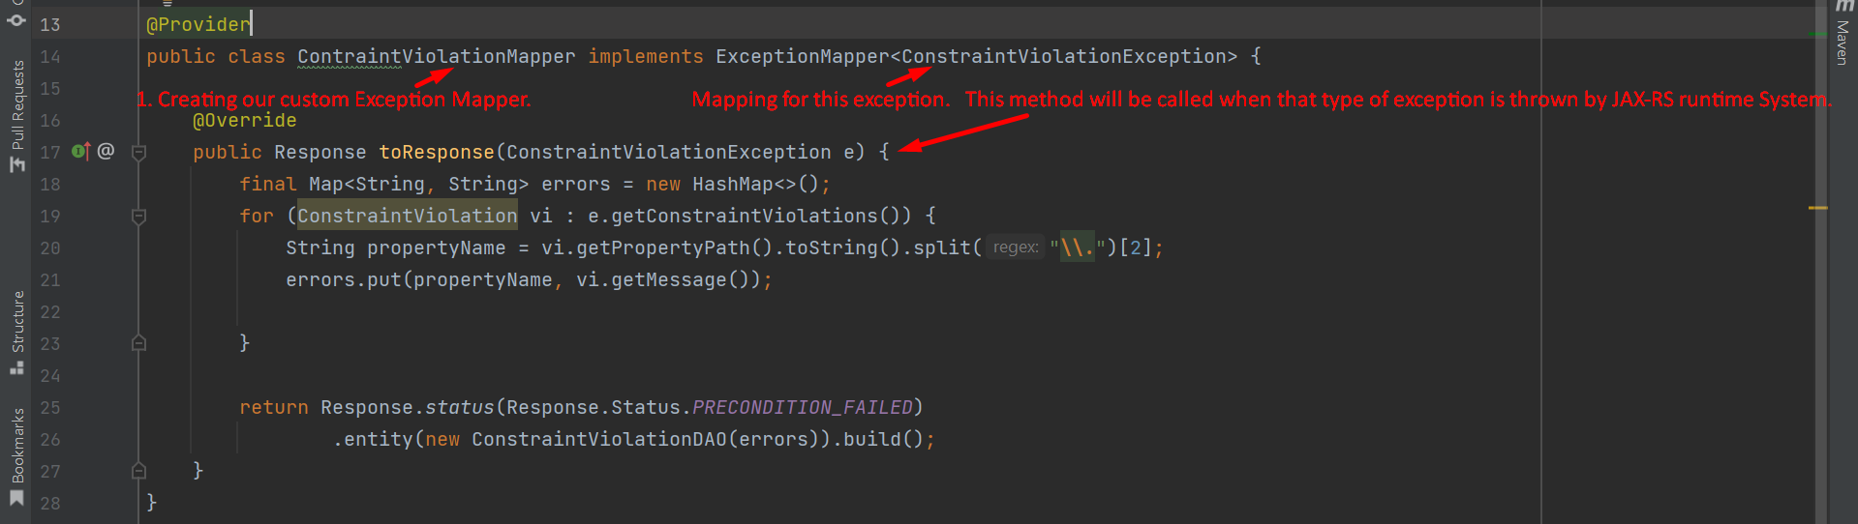
2. **The return type Response is the object we sent back to the client.**